Volunteers’ Management System
Apollo Group

User Manual




Version: 0.1
Author: Apollo Team

Revision History

Name | Date | Description | Version
Waseem Soomro | 25 Apr 10 | Created a User-Manual with initial outline | 0.1

Table of Contents
Table of Contents 3
1. Introduction 4
2. How To 5
2.1 xxx
2.2
3. Troubleshooting
5. Appendix A: Glossary 7

Introduction

This document will help the Users of the system to better use Volunteers’ Management System.
Who should refer this doc
Wt content it has the overview of the doc
Wt is the purpose of the doc

How to create crisis

Steps to create crisis
- Login as Manager, by entering username and password.

- Then open crisis board page and select “Create new crisis” menu

- System shows you new Crisis Information Page containing the map.
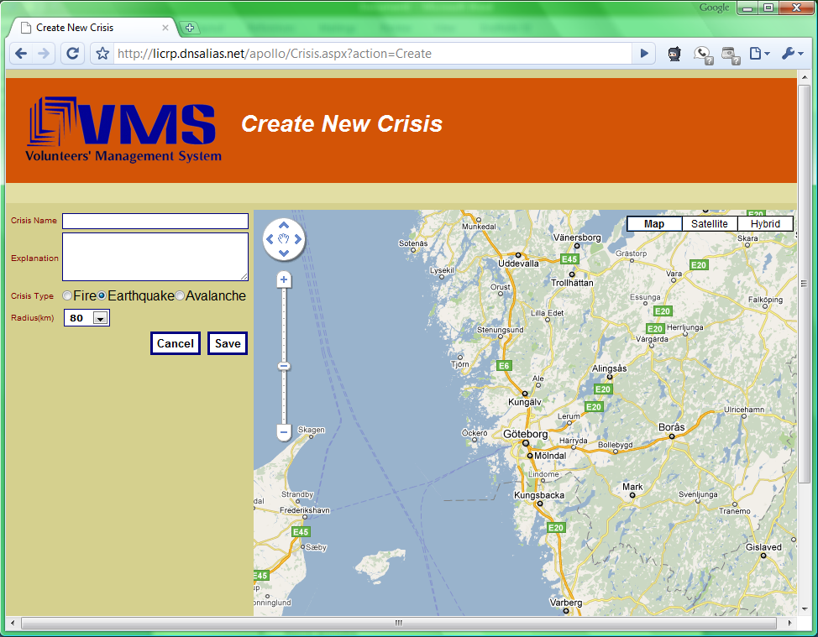
- Fills the form and saves:
  - Please a name for crisis in ‘crisis name’ field
  - Defines the crisis and area on the map by selecting the area and then clicking it
  - Selects type of the crisis from a list
  - Enters details of crisis, in explanation field
- Clicks save. Then be guided to the Management main page to perform rest of the operations.

How to register as Manager

Steps to register as Manager
- In login page, selects ‘Manager’ as user type (Manager/Volunteer) and selects “Register” menu
- Then it’ll navigate you to Managers Registration page
- Fill the required information, such as:
  - personal information.
  - Selects the incident types you are good at managing. (fire, bombing …)
  - Selects username and password.
- Presses Register button
- System verifies information, saves information, navigates to login page, shows massage about successful registration and sends data for approval.

Glossary

To be done

